## OLAP cube

The OLAP Cube consists of numeric facts called measures which are categorized by dimensions. OLAP Cube is also called the **hypercube**.

Usually, data operations and analysis are performed using the simple spreadsheet, where data values are arranged in row and column format. This is ideal for two-dimensional data. However, OLAP contains multidimensional data, with data usually obtained from a different and unrelated source. Using a spreadsheet is not an optimal option. The cube can store and analyze multidimensional data in a logical and orderly manner.

A Data warehouse would extract information from multiple data sources and formats like text files, excel sheet, multimedia files, etc.

The extracted data is cleaned and transformed. Data is loaded into an OLAP server (or OLAP cube) where information is pre-calculated in advance for further analysis.

**Basic analytical operations of OLAP**

Four types of analytical OLAP operations are:

1. Roll-up
2. Drill-down
3. Slice and dice
4. Pivot (rotate)

**1) Roll-up:**

Roll-up is also known as “consolidation” or “aggregation.” The Roll-up operation can be performed in 2 ways

1. Reducing dimensions
2. Climbing up concept hierarchy. Concept hierarchy is a system of grouping things based on their order or level.

Consider the following diagram

[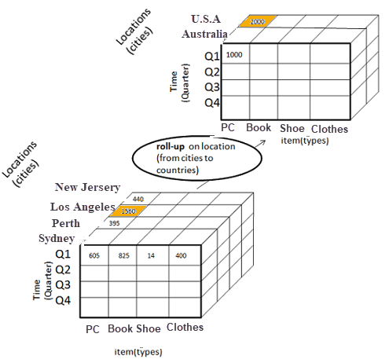](https://www.guru99.com/images/1/022218_1238_WhatisOLAPO2.png)

**Roll-up operation in OLAP**

* In this example, cities New jersey and Lost Angles and rolled up into country USA
* The sales figure of New Jersey and Los Angeles are 440 and 1560 respectively. They become 2000 after roll-up
* In this aggregation process, data is location hierarchy moves up from city to the country.
* In the roll-up process at least one or more dimensions need to be removed. In this example, Cities dimension is removed.

**2) Drill-down**

In drill-down data is fragmented into smaller parts. It is the opposite of the rollup process. It can be done via

* Moving down the concept hierarchy
* Increasing a dimension

[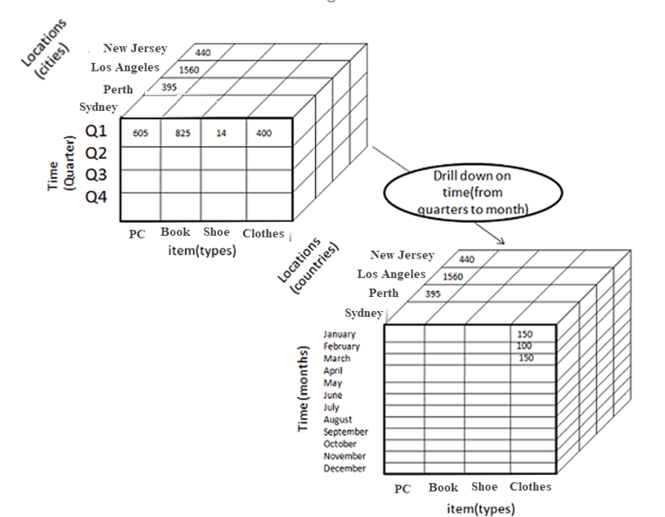](https://www.guru99.com/images/1/022218_1238_WhatisOLAPO3.png)

**Drill-down operation in OLAP**

Consider the diagram above

* Quater Q1 is drilled down to months January, February, and March. Corresponding sales are also registers.
* In this example, dimension months are added.

**3) Slice:**

Here, one dimension is selected, and a new sub-cube is created.

Following diagram explain how slice operation performed:

[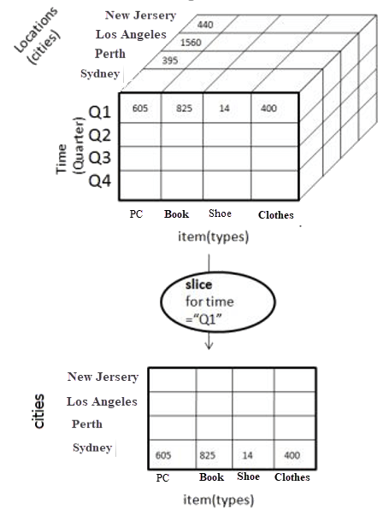](https://www.guru99.com/images/1/022218_1238_WhatisOLAPO4.png)

**Slice operation in OLAP**

* Dimension Time is Sliced with Q1 as the filter.
* A new cube is created altogether.

**Dice:**

This operation is similar to a slice. The difference in dice is you select 2 or more dimensions that result in the creation of a sub-cube.

[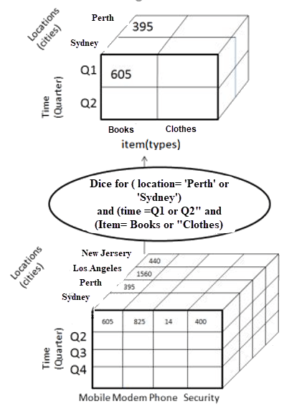](https://www.guru99.com/images/1/022218_1238_WhatisOLAPO5.png)

**Dice operation in OLAP**

**4) Pivot**

In Pivot, you rotate the data axes to provide a substitute presentation of data.

In the following example, the pivot is based on item types.

[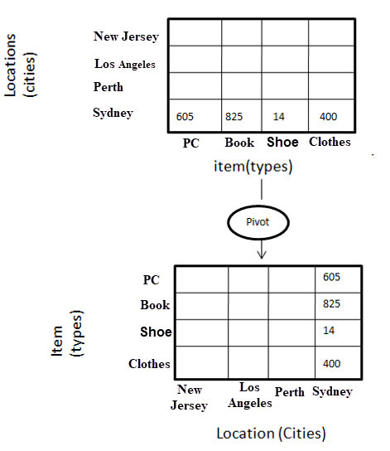](https://www.guru99.com/images/1/022218_1238_WhatisOLAPO6.png)Pivot operation in OLAP